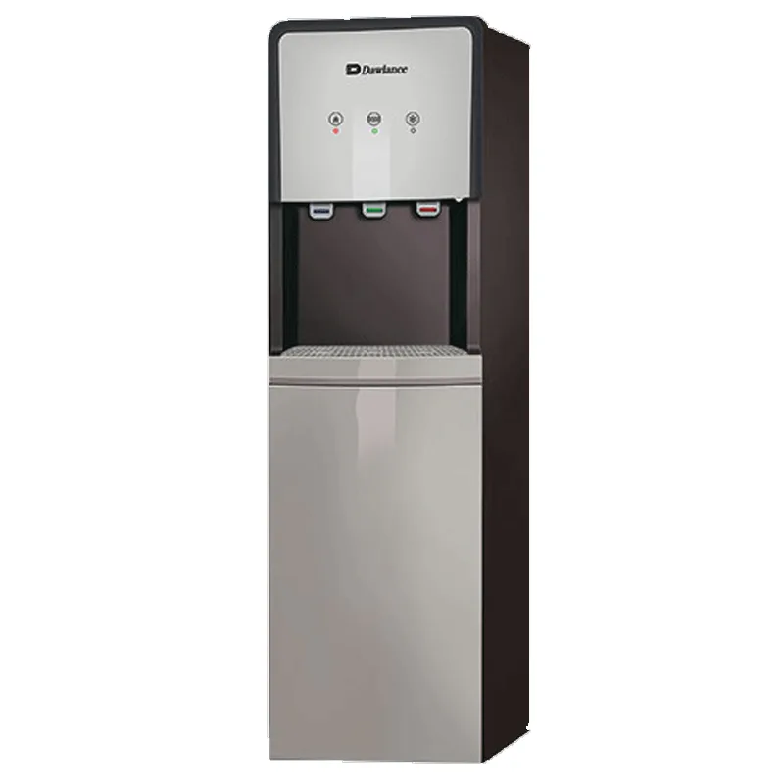

***Dawlance DWT 1775 PL e-care Top Load Water dispenser***

* **Color:**Black/Grey
* **Available:**in stock
* **Dimension:**1641*595*600
* **Size:**19
* **Old Price:**~~Rs 50,000.00~~
* **New Price:**Rs 49,500.00